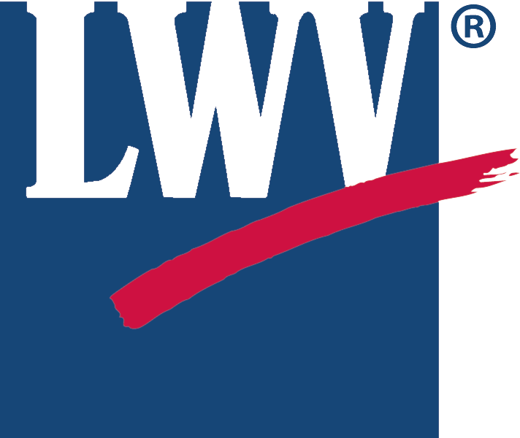 | 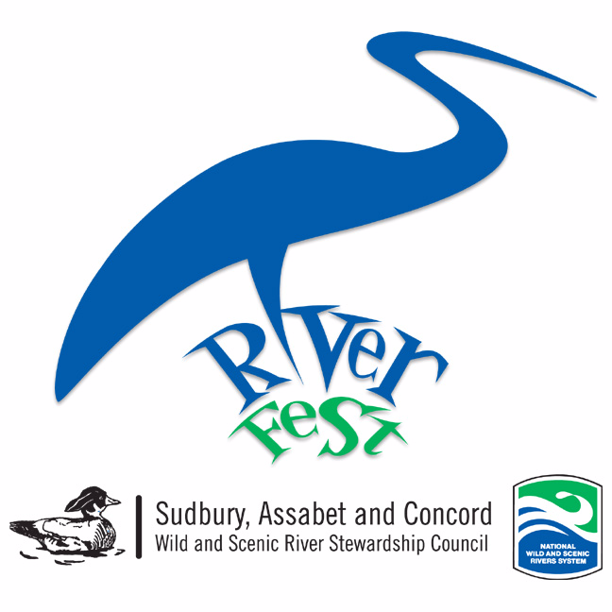

2016 RIVER STEWARDSHIP AWARD NOMINATION

Due April 11th

The League of Women Voters and the Wild and Scenic River Stewardship Council are soliciting nominations for the 14th Annual River Stewardship Award

Do you know someone who is an outstanding advocate for the Sudbury, Assabet and Concord Rivers? Is there an inspiring project or creative program that protects the beauty and health of our rivers or is dedicated to building an environmental legacy for future generations? We seek individuals, organizations, youth, teachers, businesses, government employees and others whose work will inspire children, families, and town and school leaders to protect and preserve our wild and scenic rivers.

Nominees may live or work in any of the SuAsCo watershed towns: Acton, Ashland, Bedford, Berlin, Billerica, Bolton, Boxborough, Boylston, Carlisle, Chelmsford, Clinton, Concord, Framingham, Grafton, Harvard, Holliston, Hopkinton, Hudson, Lincoln, Littleton, Lowell, Marlborough, Maynard, Natick, Northborough, Sherborn, Shrewsbury, Southborough, Stow, Sudbury, Tewksbury, Upton, Wayland, Westborough, Westford, and Weston.

As pioneers in conservation, the League of Woman Voters and the Wild and Scenic River Stewardship Council together present the River Stewardship Awards. Twenty-nine miles of the Sudbury, Assabet and Concord Rivers have been federally designated as Wild and Scenic Rivers because of their outstandingly remarkable resources including ecology, recreation, scenery, history and literature. The River Stewardship Award honors unsung heroes within the river communities who are doing their part to promote, preserve and protect the Sudbury, Assabet and Concord Wild and Scenic Rivers today, and for future generations.

2015 Award winners included:
2015 Award winners included: Pam Rockwell, Teens Representing Environmental Excellency and Stewardship (TREES), Michael Kossuth, and Anne Slugg.

Nominate yourself, your organization or a colleague.

NOMINEE

Name of Nominee(s): __________________________________________________________
Project Title: _________________________________________________________________
Project Start and End Dates: ____________________________________________________
Organization: ________________________________________________________________
Address: ____________________________________________________________________
Email: ___________________
Work Phone: ______________ Home Phone: ______________ Cell Phone: _______________

NOMINATOR

Name: _________________________________________ Email: _________________
Organization: _______________________________________________________________
Address: ____________________________________________ Phone: ________________

Please tell why the nominee should receive a River Stewardship Award by addressing the following questions in two pages or less.

- Describe the project.

- What historic, literary, scenic, recreational or ecological benefits resulted?

- How is this commitment to the environment above and beyond the ordinary?

- How has the nominee influenced others?

- Can this project be sustained over time?

- Has the nominee demonstrated innovation and creativity?

Materials such as flyers, handouts, news clippings and photos help convey the impact and benefits of the nominee’s efforts and can be included.

Do you want application materials returned to you? Yes _____ No _____

THANK YOU FOR TAKING TIME TO NOMINATE SOMEONE WHO INSPIRES YOU!

Awards will be made on June 17 at 6 pm at Wolbach Farm in Sudbury as part of the Riverfest Celebration.

Questions? Call Mary Antes, 508-358-2571, mantes2@verizon.net

Send the application and accompanying materials by April 11, 2016 to Mary Antes, 11 Old Farm Circle, Wayland, MA 01778.

